**Tearsheet Writer’s Template (Service Offering and Solutions)**

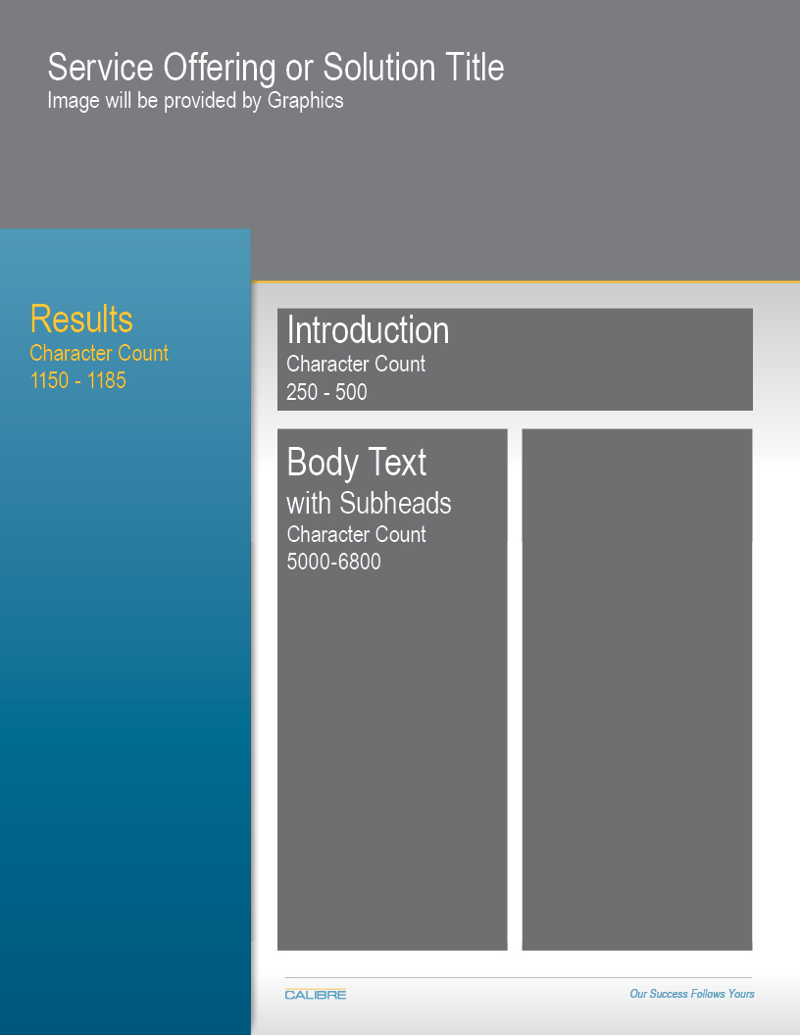

Please note the character counts for each section.

|  |  |  |  |  |  |
| --- | --- | --- | --- | --- | --- |
| POC Information: | | Evan Lynch | | evan.lynch@calibresys.com |  |
|  | | | | |  |
| Service Offering orSolution Title | |  | | |  |
| Overview: Staff-to-Door Allocation (SDA) Tool | | | | |  |
|  | | | | |  |
| Implementation Process 1150 - 1185 characters | | | | |  |
| CALIBRE is committed to ensuring the successful rollout of SDA, and understands the challenges that can come with implementing a new solution. As we roll out this new product, we’ve developed a general implementation framework that keeps your success in mind throughout every step of the process. | | | | | |
|  | 1. **Diagnostic** | Preliminary evaluation to determine how SDA can best fit within your current process. Demonstration of the SDA capability using a small subset of existing data. | | | |
|  | 1. **Pilot** | Scaled down implementation where actual decisions are being made with SDA. Typically one week to one month in duration. | | | |
|  | 1. **Lessons Learned** | Based on lessons learned during the pilot phase, operational-level tweaks will be made to ensure SDA is a solution that meets your specific needs. | | | |
|  | 1. **Implementation** | When ready, begin implementing SDA across the facility, typically through incremental phases. Deliver product and training to management team. | | | |
|  | (insert “About CALIBRE” section below, similar to the Vetted slick sheet) |  | | | |
| Intro 250 – 300 characters | |  | | |  |
| Do inbound or outbound managers at your distribution center struggle to assign their people the right amount of workload throughout the day? Does every day feel like a firefight, due to the high volatility in carton volume? | | | | |  |
| Intro II 250 – 300 characters  Top performing distribution networks have gained a competitive edge, in large part because of their ability to harness their data to make optimal decisions. SDA is a new CALIBRE solution that can empower operational-level managers to make better and faster decisions by leveraging data with a powerful, yet simple software solution. SDA is designed to make the job of an operations manager easier, while simultaneously enabling the utilization of staff to be optimized throughout the day. | | | | |  |
| Body Text with subheadings 5800 – 6800 characters | | |  | |  |
| How does SDA fit into my current resource allocation process?   * (Insert graphic from PowerPoint slide)   How do I know if SDA is the right solution for my distribution center?  SDA is most valuable for facilities that meet the following criteria:   1. Need for Improvement: There is a need to significantly improve the allocation of scarce resources, because the current approach is not yielding expected results.    * For some facilities this may mean that productivity metrics are suffering, stagnant, or inconsistent.    * Other facilities may be short-staffed, and current employees may be experiencing a constant tug-of-war for their time. 2. Decision Complexity: Managers need to make complex resource allocation decisions very quickly with several, sometimes thousands, of available options. Factors that affect the complexity of the decision process include:    * Size of the workforce    * Size of the facility    * Volume processed by the facility in a typical day    * Level of volatility in volume throughout the facility over time 3. Data Quality: The number of cartons that will be routed to a door is either known before resource allocation decisions need to be made, or can at least be modeled/predicted accurately. If neither is possible, SDA can still be used as a benchmarking tool, comparing actual performance to a more realistic ideal state | | | | |  |
|  | | | | |  |